Dominique White
Linux and Virtualization Tech
Professor Monica Fyfe
Sunday, October 12, 2025

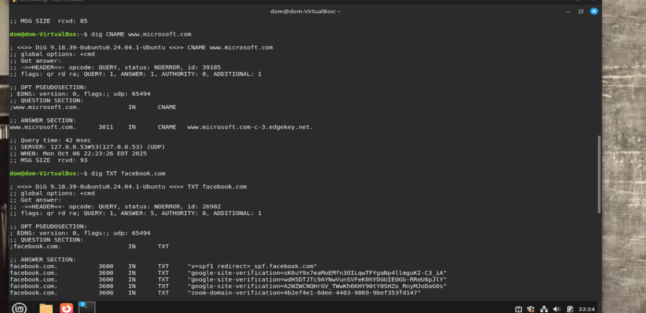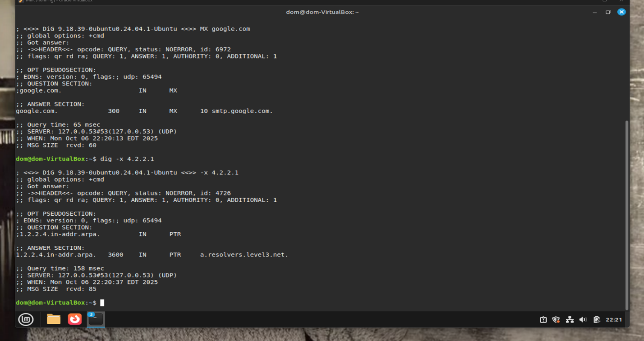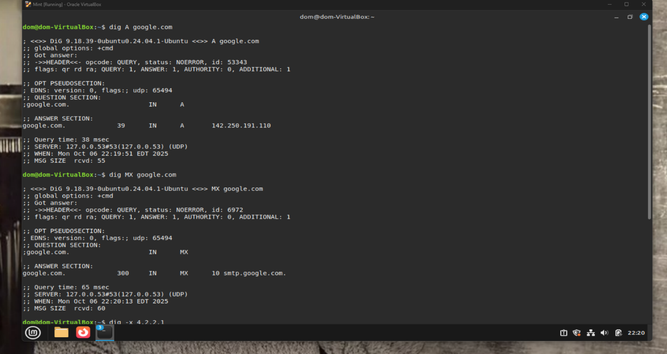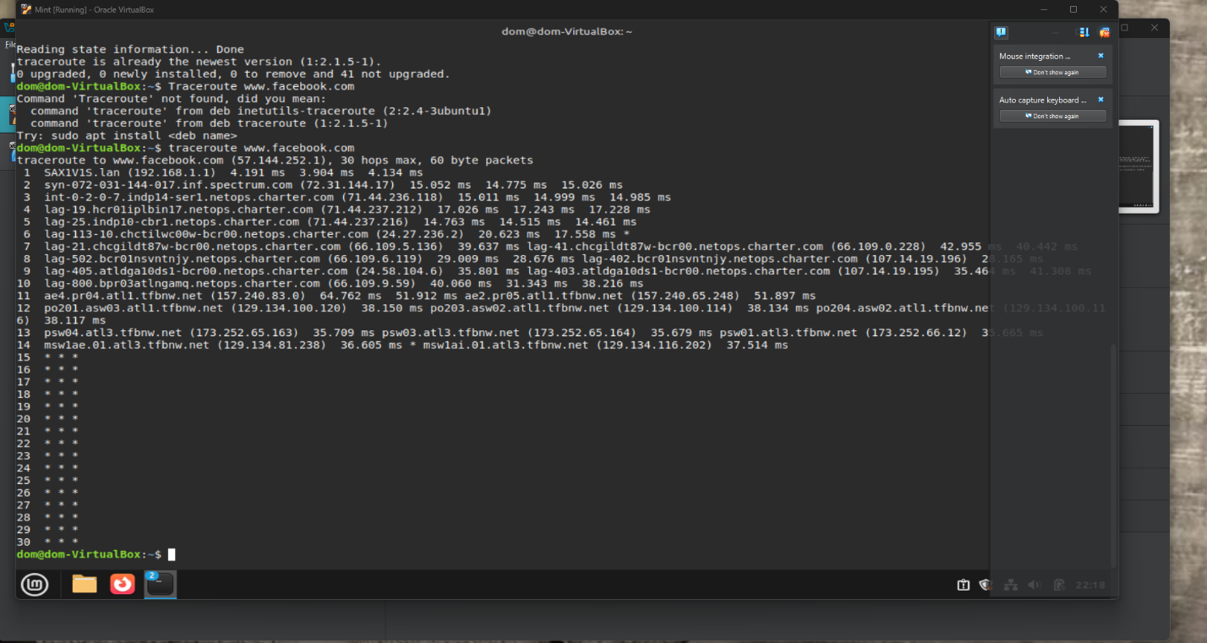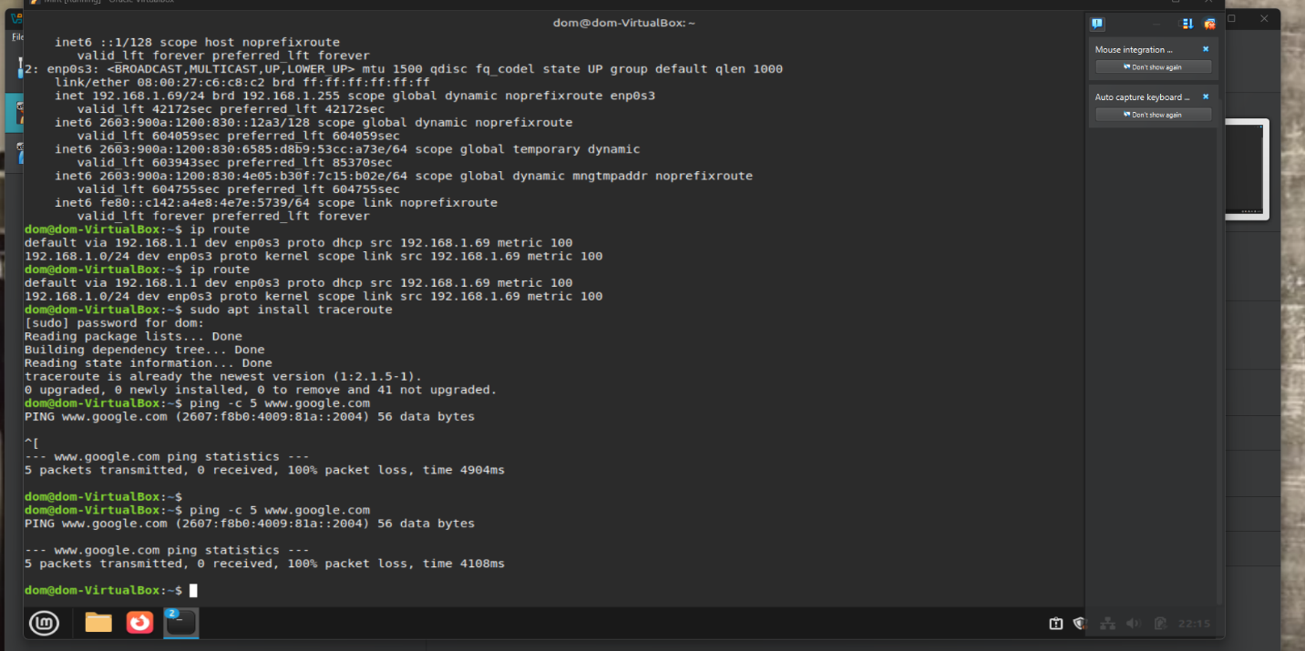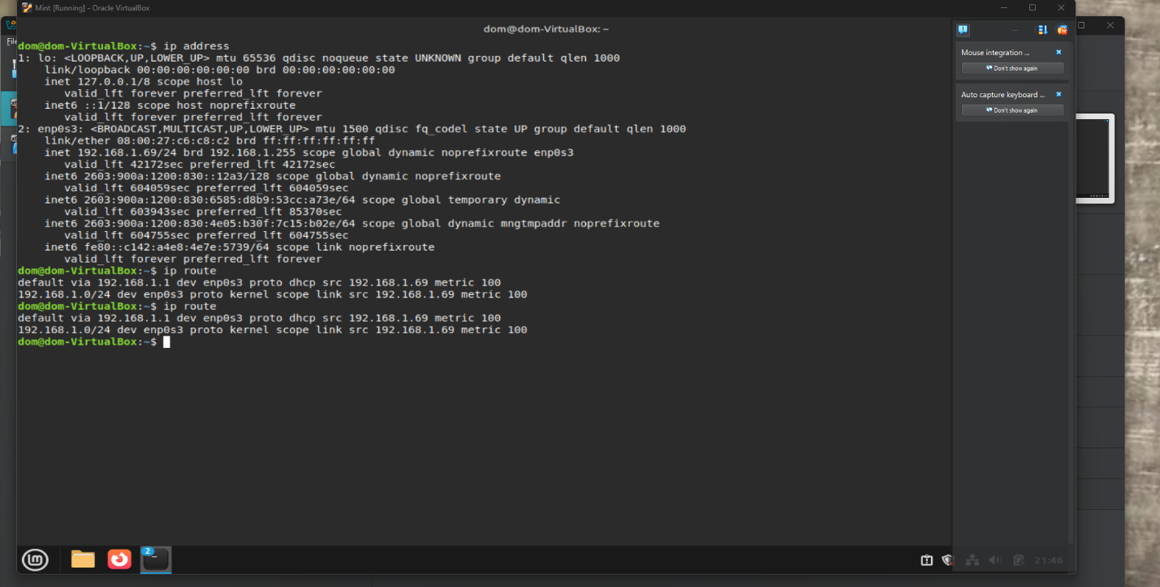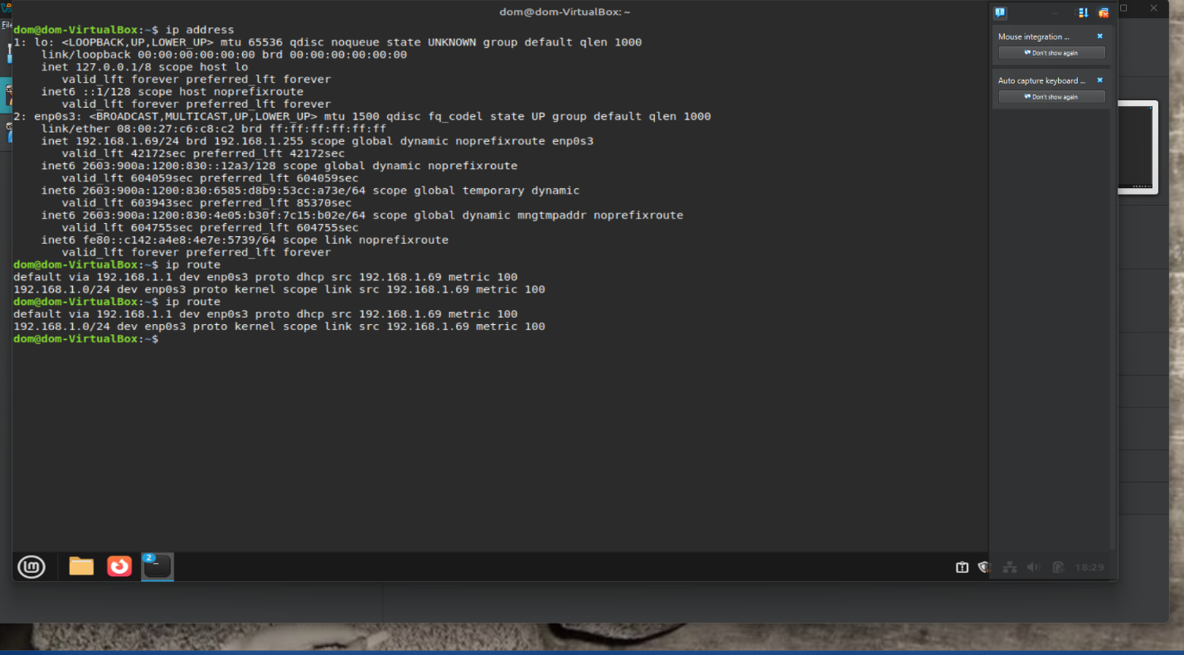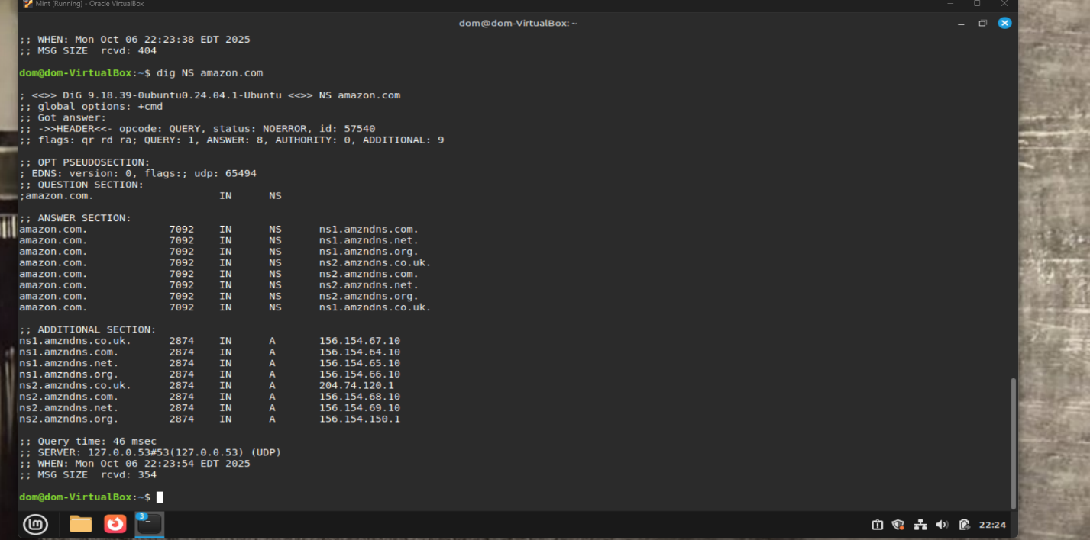

Questions to Answer
QUESTION: What is the IP address assigned to a non-loopback interface as shown by the ip address output?
IP Address: Find the inet value under your non-loopback interface. Example: 192.168.1.10

QUESTION: What is the default route as configured for the same interface as the IP address for the
previous question? (e.g., if you looked at enp1s0 for the previous question, report the default route for
the same interface.)
Default Route: From ip route, look for the line starting with default via. Example: default via 192.168.1.1 dev eth0
QUESTION: According to nmcli, what is/are the DNS server(s) your system is configured to use?
Run: nmcli

DNS Server(s): Look for IP4.DNS or dns entries in the output.
Average Ping Time: From the ping output, note the average time (e.g., avg = 23.456 ms)
Number of Hops: Count the number of lines in the traceroute output (excluding the header).
Google’s IP Address(es): Look under ANSWER SECTION for A records.
Google’s MX Record: Look under ANSWER SECTION for MX records.
FQDN for 4.2.2.1: Found in the ANSWER SECTION of the reverse lookup.
Common DNS Record Types:
- A: Maps domain to IPv4 address.
- MX: Mail exchange server for domain.
- CNAME: Canonical name (alias for another domain).

